LAB 8

Exercise 1 — Basic: ArrayList of integers
File: IntegerListDemo.java
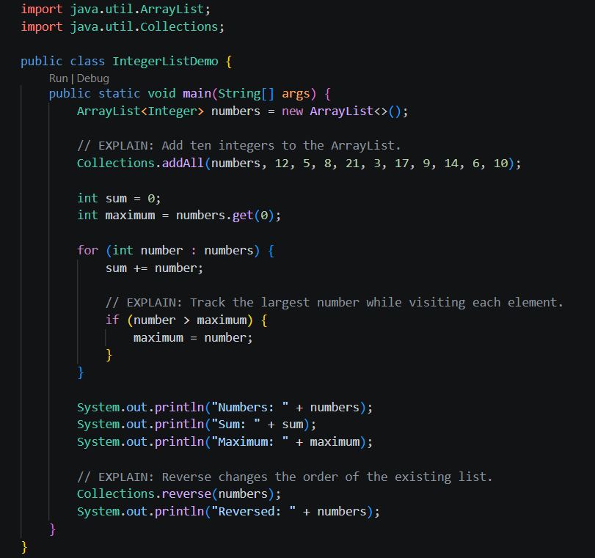
Output:
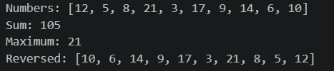

Exercise 2 — Basic: Remove duplicate names using a Set
File: UniqueNamesDemo.java

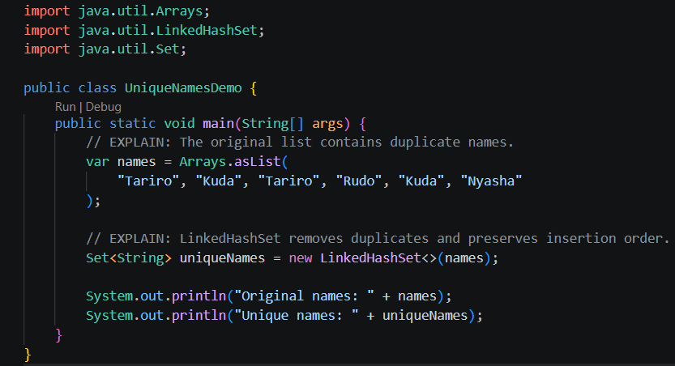
Output:

Exercise 3 — Intermediate: Generic Stack
File: GenericStackDemo.java
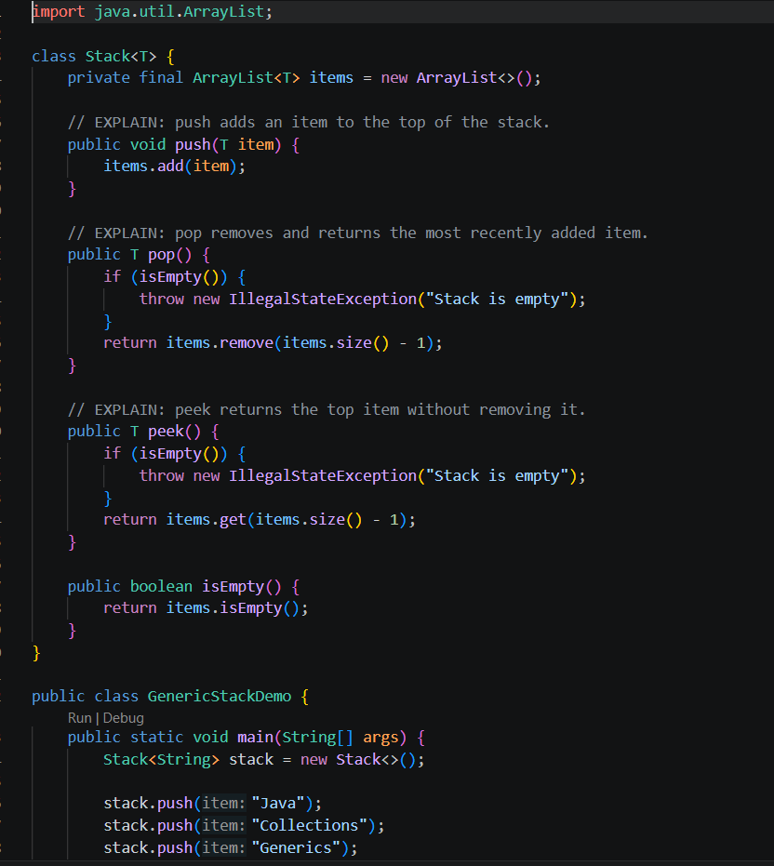
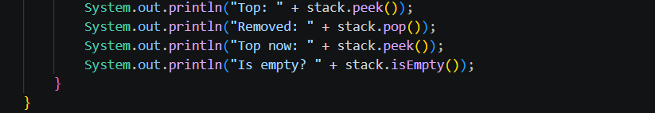

Output
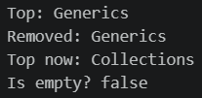

Exercise 4 — Intermediate: Word frequency using a Map
File: WordFrequencyDemo.java
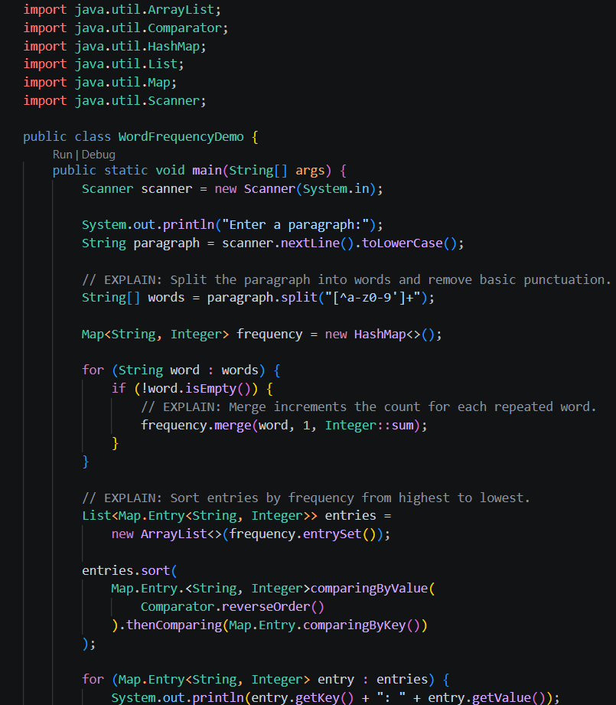
Output
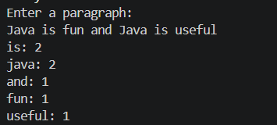

Exercise 5 — Challenge: Generic bubble sort
File: BubbleSortDemo.java
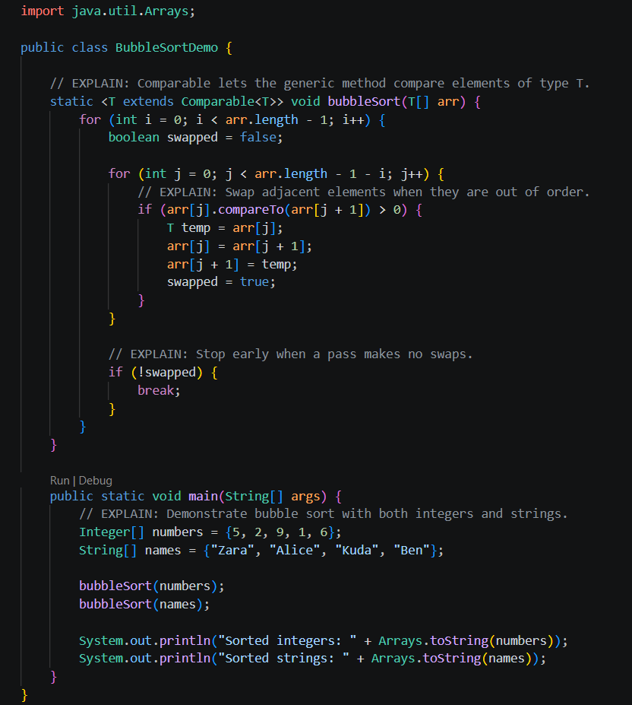
Output
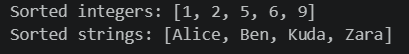
int[] will not work because the generic type parameter T must represent an object type that implements Comparable<T>. Java primitive types such as int are not objects, so use Integer[] instead. Java automatically converts between int and Integer through autoboxing and unboxing.

